## Week Six

Reduce data-driven combinations using Allpairs

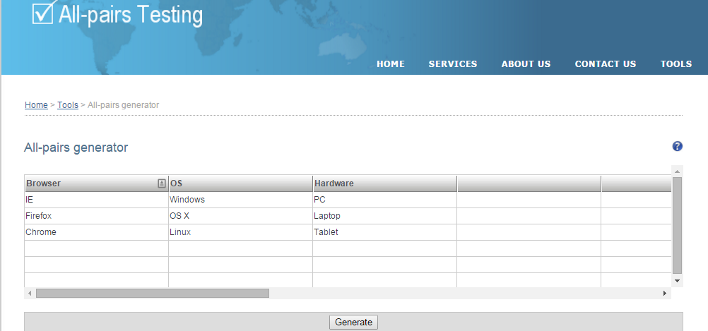

We selected a possibility of 27 combinations which includes Browser type, OS type and Hardware Form Factor type.

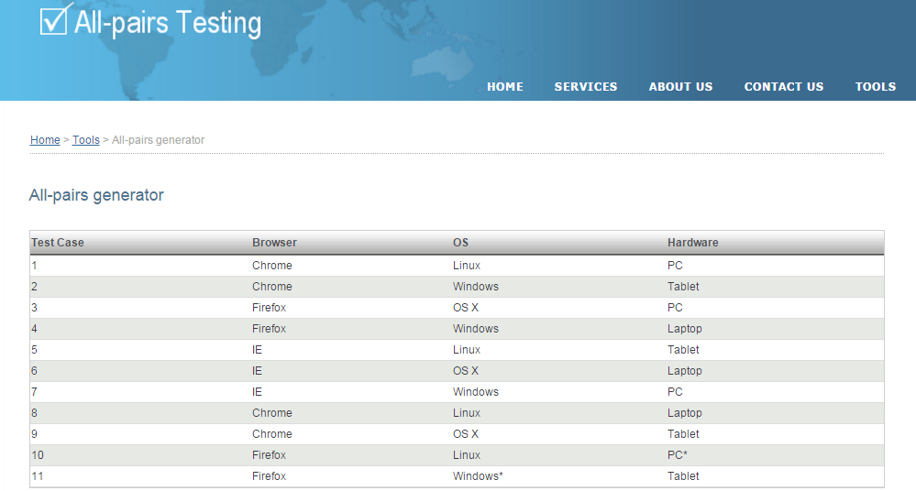

Out of the 27 combinations Allpairs gave us a result of 11 combinations to test

|  |  |  |  |
| --- | --- | --- | --- |
| Test Run | Browser | OS | Hardware |
| 1 | Chrome | Linux | PC |
| 2 | Chrome | Windows | Tablet |
| 3 | Firefox | OS X | PC |
| 4 | Firefox | Windows | Laptop |
| 5 | IE | Linux | Tablet |
| 6 | IE | OS X | Laptop |
| 7 | IE | Windows | PC |
| 8 | Chrome | Linux | Laptop |
| 9 | Chrome | OS X | Tablet |
| 10 | Firefox | Linux | PC* |
| 11 | Firefox | Windows* | Tablet |